Project Title:
*(Font Type: Times New Roman; Size: 16; Bold; Alignment: Center)
Example:
DEVELOPMENT OF REMOTE ONTROL AIRCRAFT MODEL (ROBIN) USING ALTERNATIVE MATERIAL

Category  * Please tick (√) one. | A  School (Primary & Secondary) | B  Technical Institutional Students |  | C  Academician/ Government Sector/ Entrepreneur/ Industry/ Private Sector
 | Local |  | International
Project Member(s)  *Guidelines:  Limited to 5 persons per project. | *( Full name;Font Type: Times New Roman; Size: 12; Alignment: Center)  Example:  Zainal Kadir¹, Ahmad Ali², Hazim Ismail³.
Affiliation | *(Font Type: Times New Roman; Size: 12; Alignment: Center)  Example:  ¹Faculty of Mechanical Engineering, Universiti Teknologi MARA, Cawangan Pulau Pinang, Malaysia  ²School of Mechanical Engineering, Universiti Sains Malaysia, Pulau Pinang, Malaysia  ³Automotive Research and Testing Center (ARTeC), Faculty of Mechanical Engineering, Universiti Teknologi MARA, Cawangan Pulau Pinang, Malaysia
Email | *(Font Type: Times New Roman; Size: 12; Alignment: Center)  Example:  ¹zainal@uitm.edu.my,²ahmad@uitm.edu.my, ³hazim@ppinang.uitm.edu.my
Correspondence | *(Font Type: Times New Roman; Size: 12; Full name; Alignment: Center)  Example:  Zainal Kadir  Fakulti Kejuruteraan Mekanikal,  Universiti Teknologi MARA, Cawangan Pulau Pinang,  13500 Permatang Pauh,  Pulau Pinang, Malaysia.  Tel: +604-3822568, Fax:+604-3822819
Abstract  *The abstract shall brefly describe:  - Summary (what)  - Why and how (why and how it is invented, innovated or designed)  - Advantage/main features/uniqueness  - Impact to socio economic/socio environment  - Commercialization prospect | *(Font Type: Times New Roman; Size: 12; Alignment: Justify;  at least 150 words)  Example:  The electric powered remote control aircraft model named ROBIN is constructed by using two alternative core material known as corrugated plastics and polystyrene materials. Both materials are easily obtained at local stationary store with economical cost. The corrugated plastics and polystyrene materials are more robust compared to common balsa wood material which is costly and easily breakable. The ROBIN design started from computer aided design (CAD) by using `solid edge’ software. The CAD design is used as the preliminary analysis for aircraft stability and performance. The actual ROBIN prototype was installed with the remote control electronic devices before the actual flight test. Through a series of flight test, the ROBIN design has shown to fly with high stability and maneuverability at low maintenance cost. The ROBIN prototype has great potential and capability to promote as a micro-UAV. The ROBIN micro-UAV shall provide tremendously useful information on ground mapping, surveillance, broadcasting and intelligence works.
Keywords  *Guidelines:  List of words briefly descibe your product or research area. | *(Font Type: Times New Roman; Size: 12; Alignment: Center; at least 3 keywords)  Example:  micro-UAV, aero modelling, flight performance.
Product description  *Guidelines:  Briefly describe the physical projections of the product e.g. dimension, components, special features and etc. | *(Font Type: Times New Roman; Size: 12; Alignment: Justify); at least 50 words)  Example:  ROBIN is constructed by using two alternative core material known as corrugated plastics and polystyrene materials. The actual ROBIN prototype was installed with the remote control electronic devices before the actual flight test. Through a series of flight test, the ROBIN design has shown to fly with high stability and maneuverability at low maintenance cost.
Pictures/ Schematic diagrams/ Flow Charts/Screenshots/Graphs and etc.  *Guidelines  We suggest that you use the insert picture function to insert the graphics (which is ideally a 300 dpi resolution TIFF or EPS file with all fonts embedded) because this method is somewhat more stable than directly inserting (copy-paste) a picture. | Example:  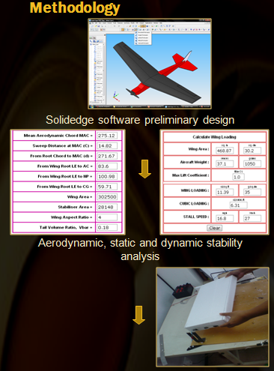  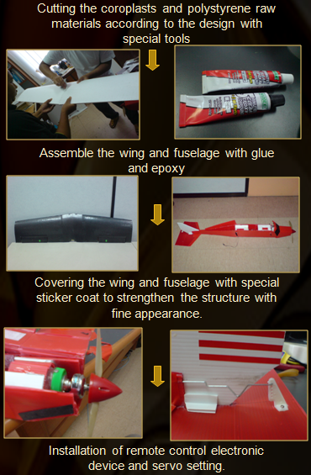
Novelty and uniqueness  *Guidelines:  Briefly descibe the origins, product uniqueness and its differentiations compared to other available products. | *(Font Type: Times New Roman; Size: 12; Alignment: Justify); at least 50 words)  Example:  ROBIN has uniqueness especially in terms of new material development. Instead of using Balsa wood, it used cheaper material for aircraft remote control model (corrugated plastic and polystyrene). Both materials offer a good crash resistance performance which is robust and conducive for aeromodelling beginner.
Benefit to mankind  *Guidelines:  Briefly descibe the product advantages, possible area of application and its benefit to the target persons or society. | *(Font Type: Times New Roman; Size: 12; Alignment: Justify); at least 50 words)  Example:  ROBIN is conducive for aeromodelling. It provides an alternative and robust method in developing a remote control aircraft. It has huge potential in assisting the aeronautical academicians or researchers to design and develop an aircraft model. It also helps the aeronautical students to comprehend the basic structure, system, aerodynamic, stability of an aircraft.
Potential commercialization  *Guidelines:  Briefly descibe the product potential inmarketability and commercialization possibilities. | *(Font Type: Times New Roman; Size: 12; Alignment: Justify); at least 50 words)  Example:  Based on physical appearance, ROBIN is practically used a hobby or toys collection for individuals. Apart from that, ROBIN can play an important role as teaching and learning equipment especially for aeronautical engineering study. With suitable equipment or payloads such as high definition camera resolution, ROBIN can be upgraded into a micro-UAV (unmanned aerial vehicle) and serves as surveillance, broadcasting and intelligence jobs.
Acknowledgment  *Guidelines:  Special acknowledgement to certain peoples or research grants. | *(Font Type: Times New Roman; Size: 12; Alignment: Justify)  Example:  The head project member acknowledges financial support from the Government of Malaysia via the sponsorship by the Ministry of Higher Education under the IPTA Academic Training Scheme. The financial support provided by the Malaysia Ministry of Higher Education’s through Fundamental Research Grant Scheme (FRGS) is acknowledged.
Researchers Biographical Data  *Guidelines:  We suggest that you use the insert picturefunction to insert the photo for each your project member(s) (which is ideally a 300 dpi resolution TIFF or EPS file with all fonts embedded) because this method is somewhat more stable than directly inserting (copy-paste) a picture. | *(Font Type: Times New Roman; Size: 12; Alignment: Justify)  Example:  Photo Zainal Kadir is a student who is currently undertaking his PhD study program under Faculty of Mechanical Engineering, UiTM, Cawangan Pulau Pinang. He was awarded a scholarship by Ministry of Higher Education of Malaysia to pursue his study in CFD and CAD field study. He is holding a Master of Science in Aerospace Engineering from Universiti Sains Malaysia.  Photo Ahmad Aliis a student who is currently undertaking his PhD study program under Faculty of Mechanical Engineering, UiTM, Cawangan Pulau Pinang. He was awarded a scholarship by Ministry of Higher Education of Malaysia to pursue his study in CFD and CAD field study.  Photo Hazim Ismailis a student who is currently undertaking his PhD study program under Faculty of Mechanical Engineering, UiTM, Cawangan Pulau Pinang. He was awarded a scholarship by Ministry of Higher Education of Malaysia to pursue his study in CFD and CAD field study. He is holding a Master of Science in Aerospace Engineering from Universiti Sains Malaysia.

Important notes:
*Please delete all the guidelines, font formatting and examples before you submit this form to the INoDEx 2025 committee.
*Please ensure the total page of filled form is maintained within 5 to 7 pages.

